Principles of Instrumentation
Photometry: means “the measurement of light”
- If a substance can be converted to a soluble, colored material, its concentration may be determined by the amount of color present in the solution.
- Photometer & Spectrophotometer are instruments used for this type of measutment, in which a photocell or photomultiplier tube is used to detect the amount of light that passes through a colored solution from a light source.
Characteristics of Light
- Light is a form of electromagnetic energy that travels in waves.
- The wavelength of light is the distance between two beaks of the light wave, it is inversely proportional with its energy.
- Objects that appear colored absorb light at particular.
Table-1(wavelengths of various types of Radiation)
Approximately wavelength | Types of radiation
< 0.1 | Gamma
0.1-10 | X-rays
<380 | Ultraviolet
380-750 | Visible
>750 | Infrared
>25 x 10⁷ | radiowaves
Table –2 (the visible Spectrum)
Color of reflected light | Color of absorbed light | Approximately wavelength
Green–Yellow | Violet | 400-435
Yellow | Blue | 435-500
Red | Green | 500-570
Blue | Yellow | 570-600
Green blue | Orange | 600-630
Green | Red | 630-700

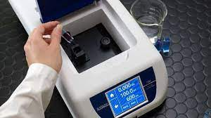
Spectrophotometer

Colorimetric determination of plasma/serum sugar level
In medicine, blood sugar is a term used to refer to the level of glucose in blood. Glucose, transported via the bloodstream, is the primary source of energy for the body cells. Blood sugar level (BSL), or serum glucose concentration, is tightly regulated in the human body so that its level remains within a certain limit (70 to 150 mg/dl) throughout the day.

The aim of this practical session is to:
- Obtain a simplified knowledge about the regulation of BSL and its clinical correlation to diabetes mellitus.
- Recognize different methods used for the determination of BSL.
- Determine the BSL in a serum sample of a fasting individual and comment on the case.

Regulation of blood sugar level

BSL is controlled by the following hormones:
- Insulin: it is a polypeptide hormone secreted from the beta cells of the islets of Langerhans in the pancreas; it lowers BSL causing hypoglycemia.

- Glucagon (secreted from the alpha cells of the islets of Langerhans in the pancreas), epinephrine (adrenaline), corticosteroids and GH raise BSL causing hyperglycemia.

Diabetes mellitus
The term “diabetes” is derived from a Greek word that means “excessive urine production”, while the term “mellitus” is a Latin word that means a “sweet taste”.

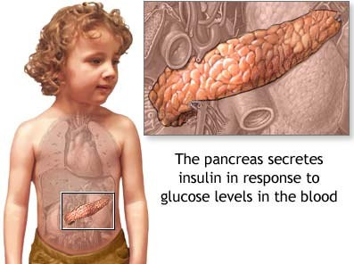

What’s the Diabetic mellitus:
The name "Diabetes mellitus” comes from the Greek word , diabetes mean passage and mellitus mean honey sweet .the diabetic definition in medical term is any disorder accompanied by a steady increased in the level of sugar level far in excess of the normal value of the state of normal metabolism in the normal person. There are 2 primary types of diabetes:
- Type 1 diabetes occurs when your immune system destroys the beta cells in the pancreas that create insulin. As a result, the body makes very little or no insulin of its own. People with type 1 diabetes must take insulin daily. Type 1 diabetes is sometimes called juvenile diabetes or insulin-dependent diabetes.
- Type 2 diabetes occurs when the pancreas does not make enough insulin, or the body cannot properly use the insulin it does create. Eventually, the pancreas may stop producing insulin altogether. Type 2 diabetes can affect people at any age. In both men and women, the more overweight an individual is, the greater the risk of developing type 2 diabetes.

Complications of Diabetes mellitus:
Diabetes mellitus can cause many complications that arise from the prolonged exposure of tissues to elevated glucose concentration. These include:
  - Renal failure.
  - Retinal damage.
  - Nerve damage.
  - Gangrene and amputation.
  - Concerning the field of dentistry, studies showed that patients with insufficient blood sugar control seem to develop gum disease more frequently and more severely than people who have good management of their diabetes, which is one of the leading causes of tooth loss among adults.

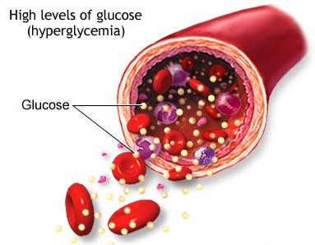
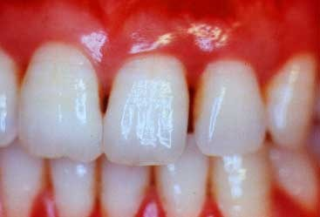

Diagnosis of Diabetes mellitus:
DM is diagnosed by demonstrating either of the following:
- Fasting BSL at or above 126 mg/dl:
N.B. The normal fasting BSL is 70-110 mg/dl; therefore, values between 110 -126 mg/dl indicate impaired fasting BSL and prediabetes.
- BSL at or above 200 mg/dl two hours after a standard oral glucose load in an oral glucose tolerance test (OGTT).
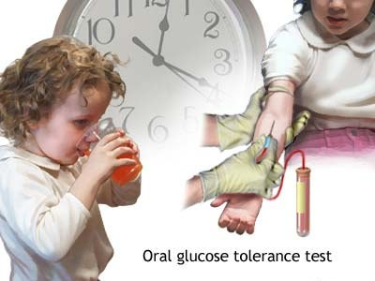
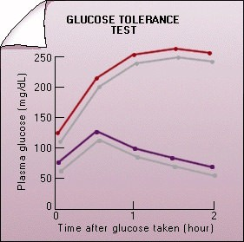

Fate of sugar in the body:

- In the normal nutrition:
starch higherdextrn erythrodextrin chrodextrine
maltose maltose maltose

glucose maltose absorption in the mucous
membrane of small intestine

- converted to glycogen and stored in muscles and liver
- converted to Co₂ and H₂O for liberation the energy
- converted to Ketone bodies and amino acids and proteins
- converted to fat and stored in adipose tissues.

- In fasting case :
Glucose-6- phosphatase
glycogen glucose-6-P glucose

Procedure:
After draw the blood and separation the serum or plasma , take 3 test tubes and marker as follow:
Addition | Blank | Standard | Sample
1-working solution | 1 ml | 1 ml | 1 ml
2-standard | --------- | 10 µl | -------
3- serum or plasma | ---------- | -------- | 10 µl

And then mix and incubation the test tubes for 10 minutes at 37 ˚C and measure absorbance of sample (A sample) and standard (A standard) against reagent blank within 30 minutes.

Calculation:
A _{sample}
A _{standard}

Glucose concentration (mg/dl) = × 100

Expected values:
Adults (fasting)= 90-120 mg/dl
Children = 60-110 mg/dl
Newborns= 40-60 mg/dl

Colorimetric estimation of plasma/serum protein level

Blood, consists of 45% formed elements (cells) and 55% plasma. Plasma (the liquid portion of blood) consists mainly of water (about 90-92%), proteins, salts, oxygen, carbon dioxide, nutrients and waste.

“Plasma proteins” are of 3 major types: albumin, globulins and fibrinogen. They are all synthesized in the liver, with the exception of the gamma globulins which are produced by B- lymphocytes.

N.B. Plasma is obtained from blood in which an anticoagulant is added, while serum is obtained when no anticoagulant is added.
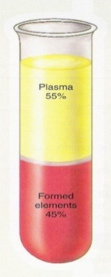

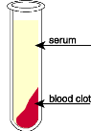
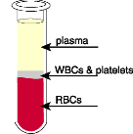

with anticoagulant without anticoagulant

Functions of plasma proteins:
- Plasma proteins maintain blood osmotic pressure, pH and volume.
- Albumin transports many substances in blood including hormones and some drugs (plasma protein-bound drugs).
- Gamma globulins (antibodies) fight infection.
- Fibrinogen is necessary for blood clotting.

Normal value of plasma proteins: The normal value of plasma proteins in humans is 6 - 8 g/dl (dl= 100 ml).

Clinical significance:
In some cases, the value of plasma proteins is lower than normal (below 6 g/dl); this is known as hypoproteinemia and can be caused by malnutrition, liver disease or severe burns. In other cases, the value of plasma proteins is higher than normal (above 8 g/dl); this is known as hyperproteinemia and can be caused by dehydration due to severe vomiting or diarrhea.

The aim of this practical session is to:

- Estimate the concentration of proteins in a plasma sample using a colorimetric method, the “Biuret method”.
- Comment on the provided case.

Biuret method for colorimetric estimation of plasma proteins

Chemical structure of proteins:
Proteins are polymeric compounds composed of “amino acids” joined together by “peptide bonds”.

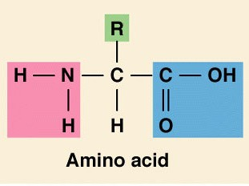

2 H₂O
+ +

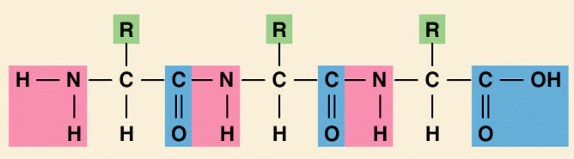
Peptide bonds

Principle of the biuret method:
- The biuret reaction is a method that can be used to determine the amount of protein in a solution.
- The biuret reagent (copper sulfate in a strong base) reacts with peptide bonds in plasma proteins to form a violet complex known as the “biuret complex”.
- N.B. Two peptide bonds at least are required for the formation of this complex.
- A colorimeter can be then used to measure the intensity of the color produced;
- the more protein present the darker the color.

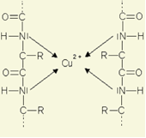

Biuret complex

- To estimate the concentration of plasma proteins, one of the two following methods can be used:
- Performing the biuret reaction on a “standard” protein solution (i.e. of known concentration) and then applying the following equation:

Ctest = Cstd  Atest / Astd
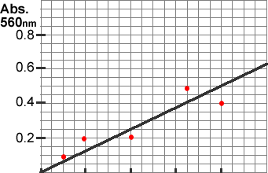
- Performing the biuret reaction on a series of standard protein solutions and then constructing a “standard curve” by plotting the absorbance on the y-axis and the concentration on the x-axis. From this curve, the absorbance reading of any sample can be converted into its coresponding concentration.
Absorbance at 550 nm

Protein concentration (g/dl)
0 2 4 6 8
Practical:
- Blood is drawn from a vein and transferred into a entrifuge tube containing an anticoagulant. In this case, blood will not clot and blood cells will settle to the bottom of the tube leaving plasma on the top.
- Plasma is obtained by centrifugation of blood for 10 minutes.
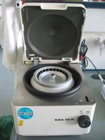
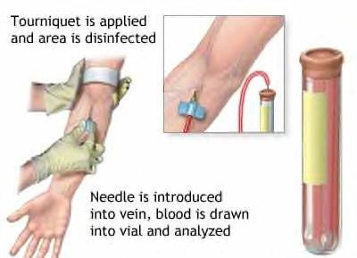
  - Determine the protein concentration in the provided plasma sample of patient 1, 2 or 3 using the biuret method as follows: In a clean dry test tube, add 0.5 ml of distilled water (blank) or plasma sample (test), then add 2 ml of biuret reagent.

 | Blank | standard | Test
Distilled water | 0.5 ml | ----
standard |  | 0.5 ml | 0.5 ml
Biuret reagent | 2 ml | 2 ml | 2 ml

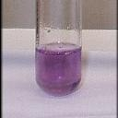
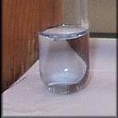
Blue violet

  - Mix the content of each tube.
  - Allow to stand for 15 minutes.
  - Read the absorbance at 550 nm.
  - Construct a “standard curve” for plasma proteins using the values in the table below showing the absorbance reading of protein solutions of different concentrations.

Concentration (g/dl) | Absorbance (at 550 nm)
0 | 0.00
1 | 0.07
2 | 0.14
4 | 0.28
7 | 0.49
10 | 0.70
12 | 0.84
  - Determine the concentration of plasma proteins (g/dl) in the provided sample.
  - Comment on the provided case.

Laboratory exercise
Student Name: ……………………………………
Student number: ……………

Laboratory exercise:
- Determine the concentration of proteins in the provided plasma sample using the biuret method.
Results: Patient number ………………..
A_{test} = ………………………….
C_{test} = …………………………..

- Write your comment on the case:
………………………………………………………………………

Colorimetric estimation of plasma/serum
albumin level

Intended Use:
Spectrum Diagnostics albumin reagent is intended for the in- vitro quantitative, diagnostic determination of albumin in human serum on both automated and manual systems.

Background:
Albumin is the major serum protein in normal individuals. It maintains the plasma colloidal osmotic pressure, binds and solubilizes many compounds such as calcium and bilirubin. Elevated serum albumin levels are usually the result of dehydration. Hyperalbuminemia is of little diagnostic significance. Hypoalbuminemia is very common in many diseases including malabsorption, liver diseases. kidney diseases, severe burns, infections, cancer and some genetic abnormalities. In severe hypoalbuminemia (less than 2.5 g/dL), the low plasma oncotic pressure allows water to move out of the blood capillaries into the tissues causing edema.
Method:
Modified bromocresol green colorimetric method:
Assay Principle: Measurement of albumin is based on its binding to the indicator dye bromocresol green (BCG) in pH 4.3 to form a blue-green colored complex. The intensity of the blue-green color is directly proportional to the concentration of albumin in the sample. It is determined by monitoring the increase in absorbance at 623 nm, or 578 nm.
Albumin + BCG pH 4.3 Albumin-BCG Complex

Procedure:

 | Blank | Standard | specimen
Reagent (R) | 2.5 ml 2.5 ml ------- 10 | 2.5 ml | 2.5 ml
Standard | --------- | 10 µl | -------
Serum/plasma | ------- |  | 10 µl

Mix , incubate for approximately 5 minutes at 20-25 oC. Measure absorbance of specimen (Aspecimen) and standard (Astandard) against reagent blank within 60 minutes.

Calculation:
A _{sample}
A _{standard}

Albumin concentration (g/dl) = × 4

Colorimetric estimation of plasma/serum
total cholesterol level

Cholesterol is a lipid sterol that is produced in and transported throughout the bloodstream in eukaryotes. Cholesterol is a critical compound used in the structure of cell membranes, hormones, and cell signaling. It is an essential component of animal cell structure in order to maintain permeability and fluidity. Cholesterol is a precursor for steroid hormones including the adrenal gland hormones cortisol and aldosterone, sex hormones progesterone, estrogens, and testosterone, and bile acids and vitamin D. Cholesterol is transported throughout the body within lipoproteins, which have cell-specific signals that direct the lipids they transport to certain tissues. For this reason, lipoproteins exist in different forms within the blood based on their density. These include chylomicrons, very-low density lipoproteins (VLDLs), low-density lipoproteins (LDLs), intermediate- density lipoproteins (IDLs), and high-density lipoproteins (HDLs). The higher the lipid content within a lipoprotein, the lower its density.
Cholesterol exists within a lipoprotein as a free alcohol and as a fatty cholesteryl ester, which is the predominant form of cholesterol transport and storage. High levels of cholesterol and cholesteryl esters (hypercholesterolemia) have been associated with cardiovascular disease such as atherosclerosis and heart disease, although lower levels

(hypocholesterolemia) may be associated with cancer, depression, or respiratory diseases.
Cell Biolabs’ Total Cholesterol Assay Kit is a simple colorimetric assay that measures the amount of total cholesterol present in plasma, serum, tissue homogenates, or cell lysates in a 96-well microtiter plate format. The assay will detect total cholesterol (cholesteryl esters plus free cholesterol) in the presence of cholesterol esterase or only free cholesterol in the absence of the esterase enzyme. Each kit provides sufficient reagents to perform up to 192 assays, including blanks, cholesterol standards and unknown samples. Sample cholesterol concentrations are determined by comparison with a known cholesterol standard.
Cholesteryl esters can be quantified by subtracting the free cholesterol values from the total cholesterol value. Colorimetric measurement procedures are less costly but are subject to interfering substances and may require extraction steps and strong acids
Classical method = Liebermann-Burchard:
Involved extraction & hydrolysis. Uses sulfuric & acetic acids. Results in formation of a green color, proportional to the cholesterol concentration.
Three step process using a coupled reaction with cholesterol oxidase.
Cholesterol ester
Cholesterol-Esterase
Free cholesterol + Fatty Acid
Free cholesterol
Cholesterol Oxidase
H₂O₂
Horseradish Peroxidase
H₂O₂
+ Chromogen
Colored Chromogen

Factors affecting on cholesterol levels:

- Anything that affects HDL & LDL levels will affect cholesterol concentration-because these lipoprotein contain increased cholesterol
- Thyroxine level inversely affects cholesterol level
- hypothyroid associated with hyper cholesterol
- hyper thyroid associated with hypo cholesterol
- Estrogens
- documented that post-menopausal women have increased LDL cholesterol
- Pregnancy
- altered endocrine function resulting in increased cholesterol
- Others include hepatitis, nephrotic syndrome, emotional stress, and Diabetes mellitus
- Cholesterol level varies with age, sex, & diet
200 mg/dL<

Calculation:
A _{sample}
A _{standard}

Cholesterol concentration (mg/dl) = × n

n= 200 mg/dl of blood =concentration of standard

Colorimetric estimation of plasma/serum
triglyceride level

Triglycerides (TGs): are essential fats (also called “lipids”) transported in our bloodstream with cholesterol. They are called triglycerides because each molecule contains three fatty acids. TGs are the major source of energy used and stored by our bodies. They come from two sources—what we eat and what our liver makes. High blood TG levels can be genetic, or caused by diabetes, thyroid problems, kidney disease, or some medicines. Triglycerides (TG) are the main constituent of vegetable oil, animal fat, LDL and VLDL, and play an important role as transporters of fatty acids as well as serving as an energy source. TG are broken down into fatty acids and glycerol, after which both can serve as substrates for energy producing and metabolic pathways. High blood levels of TG are implicated in atherosclerosis, heart disease and stroke as well as in pancreatitis.
Principle: The concentration of serum triglyceride was measured by using a special chemical kit based on:
TG + H₂O₂ glycerol + fatty acids
Glycerol + ATP glycerol-3-phosphate + ADP
Glycerol-3-phosphate + O₂ Dihydroxy acetone + H₂O₂

2H₂O₂ + 4 aminoantipyrine + ADPS red quinon imine +4H₂O

Procedure of measurement:

The procedure of this kit is as:

Solution | Blank | Standard | Sample
Reagent | 1 ml | 1 ml | 1ml
Standard | ------ | 10µl | ------
Serum | ------ | ------- | 10µl

After adding, mix and incubate the test tubes for 5 min. at 20°C or 10 min. at 37°C. Then read the optical density (OD) of standards and samples against blank at 520 nm. Calculated the serum TG concentration by the following formula:
A sample
A standard

TG concentration = X n = mg/dl of blood

n = standard concentration= 200 mg/dl

Colorimetric estimation of plasma/serum High-Density Lipoprotein Cholesterol level (HDL-C)

The principle role of HDL in the lipid metabolism is the uptake and transport of cholesterol from peripheral tissues to the liver through a process known as reveres cholesterol transport.
The principle:
This reagent is only used for treatment of specimens before the determination of HDL-C with a reagent for total cholesterol. Low density lipoprotein (LDL), very low density lipoprotein (VLDL) and chylomicrons from specimens are precipitated by phosphotungstic acid (PTA) and magnesium chloride. HDL-C obtained in the supernatant after centrifugation is then measured with a total cholesterol reagent
Procedure: Do not treat standard (vial R₂) enclosed in kit:
Solution | Macro-method | Micro-method
Specimen | 1 ml | 0.5 ml
Precipitant | 100 µl | 50 µl

Mix vigorously, let stand for 10 min. at room temperature and centrifuge for 15 min. at 3500-4000 RPM. with BIOLAB total cholesterol CHOD-PAP or equivalent: Let stand reagents and

supernatants at room temperature. Calibrate with standard enclosed in the kit or pre- treated series calibrator.
Solution | Blank | Standard | Sample
Reagent | 1 ml | 1 ml | 1ml
Standard | ------ | 25µl | ------
Serum | ------ | ------- | 25µl
Distal water | 25µl | ------ | -------

Mix well the test tubes and let stand for 5 min. at 37°C or 10 min. at room temperature. Record absorbance at 500 nm. (480-520 nm) against the reagent blank.
A _{sample}
A _{standard}
HDL concentration = X Standard concentration X1.1

1.1= standard remaining undiluted, 1.1 factor takes into account dilution of the specimen during the precipitation step.

Serum Low-Density Lipoprotein (LDL):

Serum LDL concentration can be calculated by the following equation: LDL= TC- (HDL+TG/5)
Serum Very Low-Density Lipoprotein (VLDL):
Serum VLDL concentration was calculated by dividing serum TG/5. VLDL=TG/5

Colorimetric estimation of plasma/serum
urea level
Urea is the major end product of protein nitrogen metabolism. It is synthesized by the urea cycle in the liver and excreted through the kidneys. The circulating levels of urea depend upon protein intake, protein catabolism and kidney function. Elevated urea levels can occur due to renal impairment or in some diseases such as diabetes, infection, congestive heart failure and during different liver diseases. Determination of blood urea nitrogen is the most widely used screening test for renal function together with serum creatinine.
The concentration of urea in the blood serum represent mainly a balance between urea formation from protein catabolism and urea excretion by kidney. If kidney fail , blood urea Conc. Increase to high level and toxic condition known as (Uremia ) will result .
In uremia, urea must be removed from the blood by clinical procedure called “Blood Dialysis “
Blood Urea Nitrogen (BUN)

- Sometime used as measurement of serum urea ½ Mwt of Urea is Nitrogen.
Normal range:
Serum urea ( 10-50 ) mg/dl
BUN ( 5- 25) mg/dl
Adults < 65 years = 15-50 mg/dl
Adults > 65 years= < 70 mg/dlSerum urea normally varies depending on:
- Age ( due to change kidney function )
- Sex ( conc. are slightly higher in men )
- Diet ( protein diet Urea )

Fate of protein inside the body:

inner source

outer source
from food

Total

excretion
Pools of amino acid
Proteins of tissues
Biosynthesis
(anabolism)

Converted to non-protein
Nitrogenous compounds

Excess amino acids

Amino replacement

Amino drawing

Ammonia excretion with urin

O
NH₂
NH₂ C
From ammonia
From CO₂
From aspartic acids
Chemical structure of urea:

The urea synthesis in the liver from arginine (a.a.) by assessment of arginase enzyme . When the urea can't synthesis for any causes due to increase the level of ammonia in the body which is toxic compound and cause death.

The urea increase in the kidney diseases like:
1- chronic nephritis 2-Glomerular nephritis
3- Nephrosclerosis by close the urinary tract as a result of the presence of stone.
4- Prostate enlargement or swelling of the bladder and ureters.
Procedure:
After draw the blood and separation the serum or plasma , take 3 test tubes and marker as follow:
Procedure: Prefer as followed:
`Solution | Blank | Standard | Sample
Working Solution  Standard  Sample (serum) | 1 ml  -------  ------ | 1ml  10µl  -------- | 1ml  -------  10µl
Mix, incubate the test tubes for at least 3min. at 37 °C or 5 min. at 20-25 °C
Alkaline Reagent (R₃) | 20µl | 20µl | 20µl
Mix and incubate for 5 min. at 37°Cor 10 min. at 20 to 25°C.
Measure absorbance of specimen and standard against reagent blank within 30 minutes on wavelength 578nm.

Calculation:
A _{specimen}
A _{standard}
Serum Urea Concentration = X n = mg/dl of blood

*n= 50 mg/dl of blood = concentration of standard
Expected values:
Adults < 65 years = 15-50 mg/dl
Adults > 65 years= < 70 mg/dl

Colorimetric estimation of plasma/serum amylase level

Amylase is an enzyme that helps digest carbohydrates. It is produced in the pancreas and the glands that make saliva. When the pancreas is diseased or inflamed, amylase releases into the blood. A test can be done to measure the level of this enzyme in a blood.
Amylase in serum arise mainly from the pancreas (P-amylase) and the salivary gland (S-amylase). Serum P- amylase activity is a more sensitive and more specific test than total amylase for the detection of acute pancreatitis.
Why the Test is Performed
• This test is most often used to diagnose or monitor acute pancreatitis. It may also detect some digestive tract problems.
The test may be done for
• Chronic pancreatitis
• Pancreatic pseudocyst
Chronic pancreatitis: Chronic pancreatitis is inflammation of the pancreas that does not heal or improve, gets worse over time, and leads to permanent damage.
Pancreatic pseudocyst: A pancreatic pseudocyst is a fluid-filled sac in the abdomen, which may also contain tissue from the pancreas, pancreatic enzymes, and blood.

Range of expected values:
Serum : 16-108 U/L
Urine: 0 - 14 U/Hour
low values in Serum is may due liver diseases and pancreatic insufficiency
Principle:
Amylase hydrolyzed p-nitrophenyl D-maltoheptoside (PNPG7) to P-nitrophenylmaltotriose (PNPG3) and maltotetrose . Glucoamylase hydrolyzes PNG3 to P-nitrophenylglycosie (PNPG1) and glucose. Then PNPG1 is hydrolyzed by glycosidase to glucose and P-nitrophenol which produce a yellow color. The rate of increase in Ab is measured at 405nm and is proportional to the amylase activity in the sample.
Materials:
Glassware:
1. Accurate pipetting devices.
2. Test tubes / rack
3. Timing device.
4. Heating block /bath (37 oC).
5. Spectrophotometer capable of reading at 405 nm (400-420 nm).
The cuvette compartment should be temperature controlled to maintain temperature (37 oC) during the assay.
Method:
Chemicals: SAMPLE 1
Amylase substrate (PNPG7):
1.0 ml Pre-warm at 37oC for 5 minutes and add:
Sample1 0.025 ml

Continue readings every 30 seconds for 2 minutes and determine ∆A/Min. Mix and incubate at 37oC for 90 seconds and read the absorbance at 405 nm against distilled water.
Results:
Absorbance AT 405
A 0 S
A 30 S
A 60 S
A 90 S
A 120 S
Calculations:
Amylase Activity in TEST (U/L) = ∆A/Min x 4824
∆A/Min = (∆A1+ ∆A2)÷2
∆A1= (A 60 s – A30 s)+( A30 s-A0 s)
∆A2= (A 120 s – A90 s)+( A90 s-A60 s)

Colorimetric estimation of plasma/serum phosphorus level
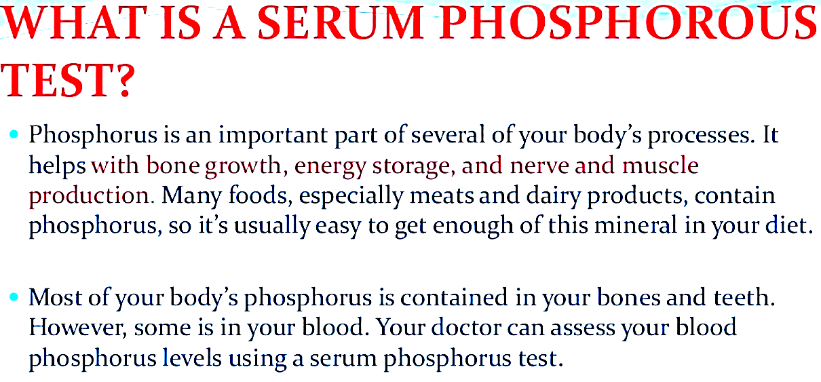
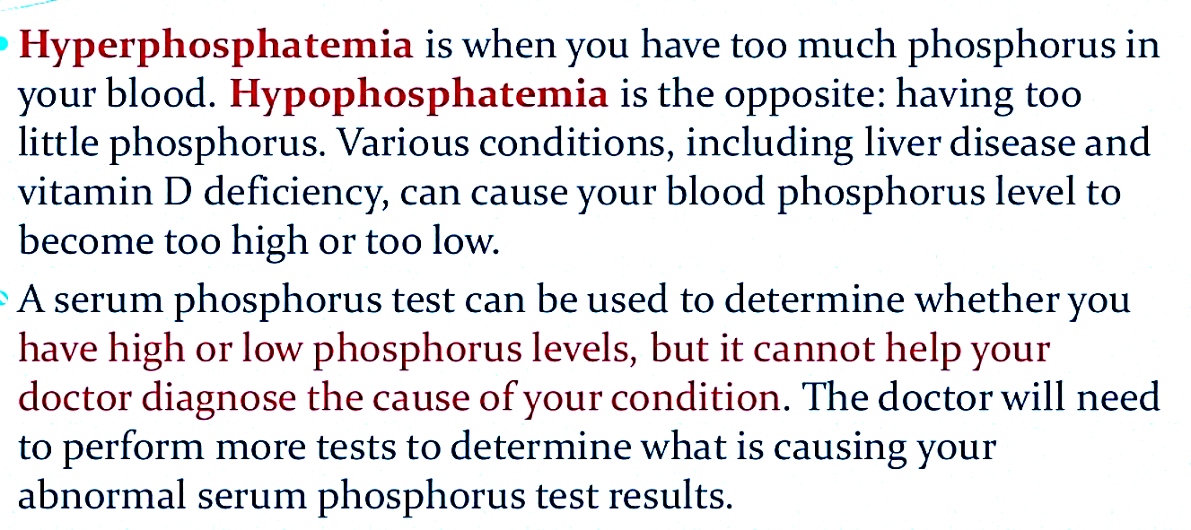

Clinical significance:
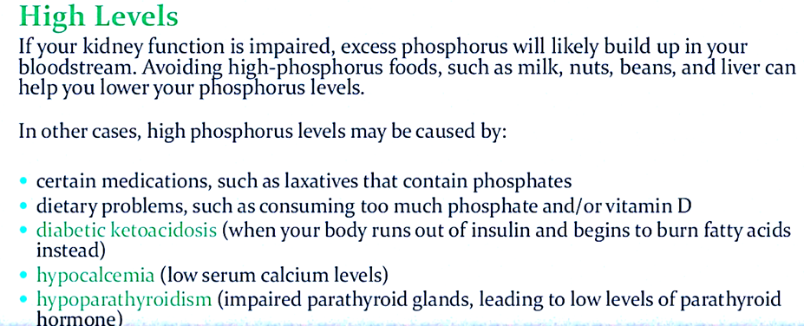
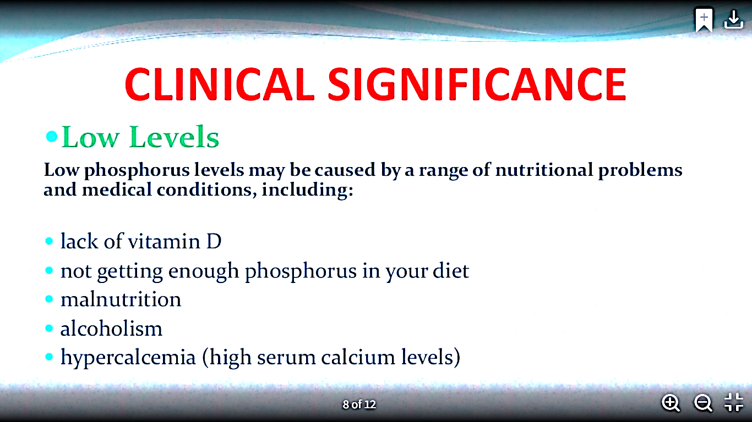

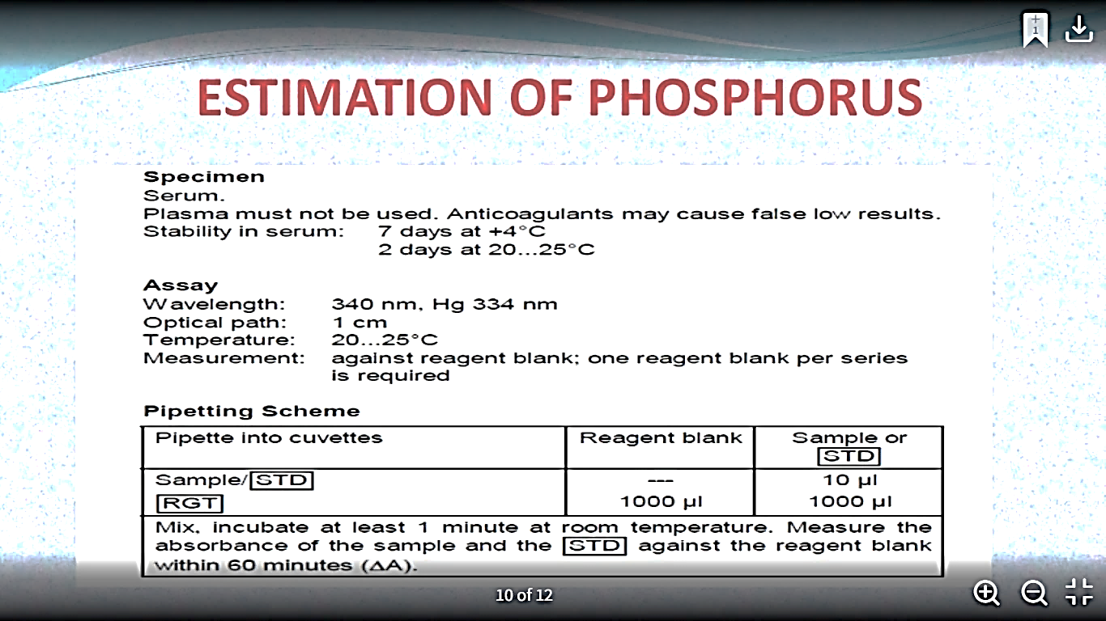
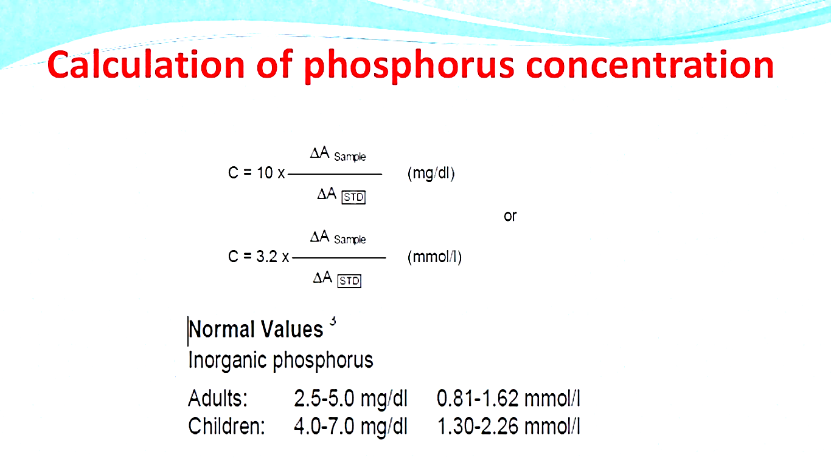

Colorimetric estimation of plasma/serum bilirubin level (Total & Direct)
To estimate the amount of bilirubin in serum.
- Bilirubin
It is a by-product of the breakdown of hemoglobin.
- Types of Bilirubin
- Direct bilirubin: Conjugated with glucoronic acid
- Indirect bilirubin: unconjugated, insoluble in water
- Total bilirubin: sum of the direct and indirect of bilirubin.
Notes: About 200 mg per day of unconjugated bilirubin are transported to the liver
Above about 2 mg/dl in the blood, leads to disease called Jaundice.
Bilirubin and jaundice
- Jaundice is caused by a build-up of bilirubin (yellow color) in the blood and tissues of the body.
- Jaundice is the discoloration of skin and sclera of the eye caused by high concentration of bilirubin.
- The causes of jaundice may be classified as: Types of jaundice
Pre-Hepatic Jaundice : Hemolytic disease
Hepatic Jaundice :-Cirrhosis of the liver, -Infective Hepatitis and-Neonatal Jaundice
Post-Hepatic Jaundice :Cholecystitis and 1-Pre-Hepatic Jaundice
Hemolytic disease (excess hemolysis)
  - The production of un-conjugated bilirubin may exceed the conjugating capacity of the liver and hence the serum levels of indirect (and of total) bilirubin will be raised and that of direct in the upper normal range or just a little elevated.
  - briefly ,Indirect bilirubin ----------- increased
Direct bilirubin---------------- little increased
Total bilirubin ----------------- increased excess hemolysis
Unconjugated bilirubin (in blood) upper normal range conjugated bilirubin (released to bile duct)
2-Hepatic Jaundice
Cirrhosis (in the absence of infection)
  - Destruction of liver cells will lead to a reduced conjugating capacity with a:
    - Raised serum level of indirect (and of total) bilirubin,
    - with a low level of direct bilirubin
2-Hepatic Jaundice
Hepatitis (in the presense of infection)
  - The conjugative capacity of the liver is approximately normal, but there is the inability to transport the conjugated bilirubin from the liver cells to the biliary system, and it will be regurgitated back into the blood.
  - Hence:
    - The serum level of unconjugated bilirubin will be normal
    - and that of conjugated (and total) bilirubin will be raised.
Neonatal Jaundice
  - Conjugating enzymes in the liver are often absent at birth.
  - Hence:
    - Raised serum level of indirect (and total) bilirubin is to be expected
    - Low level of direct bilirubin.
  - The indirect bilirubin level will rise for the first few days after birth until the conjugating enzymes begin to synthesize.
  - If the conjugation process is delayed and the serum level of indirect bilirubin rises towards 20 mg/dl, an ultraviolet therapy or an exchange blood transfusion should be carried out owing to the danger of deposition of the insoluble unconjugated bilirubin in the basal ganglia of the brain leading permanent Brain Damage.
2-Hepatic Jaundice
3-Post-Hepatic Jaundice
Cholecystitis The bile duct is blocked.
    - Hence: The indirect bilirubin level is normal but conjugated bilirubin is regurgitated into the blood and excreted into the urine (raised conjugated and total bilirubin).
- Bilirubin in serum is coupled with diazotized sulphanilic acid to form azobilirubin .
- The intensity of the purple color that is formed is proptional to the bilirubin concentration in the serum.
- The water soluble conjugated bilirubin (direct bilirubin) reacts easily with reagents such as diazotized sulphanilic acid. ( with one minute)
- while the water insoluble unconjugated bilirubin (indirect bilirubin) requires methanol, in order to accelerates the react with the diazotized sulphanilic acid.
- In this experiment, the direct bilirubin is estimated in the absence of the solubilizing agent and then further bilirubin estimation in the presence of methanole will give the total bilirubin level.
- The indirect or unconjugated bilirubin is then found by difference.

Method:
Label 4 tubes as TT (total test), TB ( total Blank), DT (direct test), DB (direct Blank).

Total Bilirubin |  | Direct Bilirubin
Test | Test Blank | Test | Test Blank
0.5ml  0.02ml | 0.5 ml  -- | 1.0 ml  0.02 ml | 1.0 ml  -- | Sulfanilic Acid Reagent  Sodium Nitrite Reagent
Mix and let stand for at least 1 min but no longer than 3min then add:
0.05 ml | 0.05 ml | 0.05 ml | 0.05 ml | Sample
After exactly 1 min . Read the absorbance of test and Test and Test Blank
(of Direct bilirubin only) at 546 nm against distalled water . For Total Bilirubin add:
0.5 ml | 0.5 ml | -- | -- | Methanol
Mix and let stand for 5 min at room temperature and read the absorbance of test and test blank ( of Total Bilirubin) at 546 nm against distilled water

Calculation :
  - Concentration of direct bilirubin = (abs. Test - abs. Test Blank ) X 25m= mg /dl
    - Normal range: Up to 0.5 mg/dl
  - Concentration of total bilirubin = (abs. Test - abs. Test Blank )X 25 = mg /dl
    - Normal range: Up to 1 mg/dl
  - Concentration of indirect bilirubin = Conc of total bilirubin – Conc of direct bilirubin= mg /dl
      - Normal range: 0.1-0.4 mg/dl
Kidney Function Tests
Objectives: Upon completion of lectures, students should be able to:
  - know the physiological functions of the kidney.
  - describe the structure and function of the nephron.
  - identify the biochemical kidney function tests with special emphasis on when to ask for the test, the indications and limitations of each kidney function tests.
  - interpret the kidney function tests properly.
Contents:
- Functional units
- Kidney functions
- Routine kidney function tests (KFTs):
    - Serum creatinine
    - Creatinine clearance
    - Cockcroft-Gault formula for GFR estimation
    - Serum Urea
Functional units :
- The nephron is the functional unit of the kidney
- Each kidney contains about 1,000,000 to 1,300,000 nephrons.
- The nephron is composed of glomerulus and renal tubules.
- The nephron performs its homeostatic function by ultra filtration at glomerulus and secretion and reabsorption at renal tubules.

Representation of a nephron and its blood supply:
Regulation of : - water and electrolyte balance.
- acid base balance. - arterial blood pressure.
    - Excretion of metabolic waste products and foreign chemicals.
    - Hormonal Function: Secretion of erythropoietin & activation of vitamin D and activation of angiotensinogen by renin
    - Metabolic Function: site for gluconeogenesis
Kidney functions:
- Many diseases affect renal function.
- In some, several functions are affected.
- In others, there is selective impairment of glomerular function or one or more of tubular functions.
- Most types of renal diseases cause destruction of complete nephron.
Why to test the renal functions?
Routine KFTs include the measurement of :
  - Serum creatinine (Cr).
  - Creatinine clearance.
  - Serum urea.
Both serum Cr and creatinine clearance are used as kidney function tests to :
  - Confirm the diagnosis of renal disease.
  - Give an idea about the severity of the disease.
  - Follow up the treatment.
Serum creatinine (55-120 μmol/L in adult):
- Creatinine is the end product of creatine catabolism.
- 98% of the body creatine is present in the muscles where it functions as store of high energy in the form of creatine phosphate.
- About 1-2 % of total muscle creatine or creatine phosphate pool is converted daily to creatinine through the spontaneous, non enzymatic loss of water or phosphate.
Serum creatinine (55-120 μmol/L in adult):
- Creatinine in the plasma is filtered freely at the glomerulus and secreted by renal tubules (10 % of urinary creatinine).
- Creatinine is not reabsorbed by the renal tubules.
- Plasma creatinine is an endogenous substance not affected by diet.
- Plasma creatinine remains fairly constant throughout adult life.
- The glomerular filtration rate (GFR) provides a useful index of the number of functioning glomeruli.
- It gives an estimation of the degree of renal impairment by disease.
Creatinine clearance: Accurate measurement of GRF by clearance tests requires determination of the concentration in plasma and urine of a substance that is:
• Freely filtered at glomeruli.
• Neither reabsorbed nor secreted by tubules.
• Its concentration in plasma needs to remains constant throughout the period of urine collection.
• Better if the substance is present endogenously.
• Easily measured.
Creatinine meets most of these criteria:
  - Creatinine clearance is usually about 110 ml/min in the 20-40 year old adults.
  - It falls slowly but progressively to about 70 ml/min in individuals over 8o years of age.
  - In children, the GFR should be related to surface area, when this is done, results are similar to those found in young adults.
  - Clearance is the volume of plasma cleared from he substance excreted in urine per minute.
  - It could be calculated from the following equation:
Clearance (ml/min) = U × V
P
U = Concentration of creatinine in urine μmol/l , V = Volume of urine per min
P = Concentration of creatinine in serum μmol/l
Cockcroft-Gault Formula
for Estimation of GFR
  - As indicated above, the creatinine clearance is measured by using a 24-hour urine collection, but this does introduce the potential for errors in terms of completion of the collection.
  - An alternative and convenient method is to employ various formulae devised to calculate creatinine clearance using parameters such as serum creatinine level, sex, age, and weight of the subject.
An example is the Cockcroft-Gault Formula:
K × (140 – age) × Body weight
GFR = ──────────────────
Serum creatinine (μmol/L)
Where K is a constant that varies with sex:1.23 for male & 1.04 for females.
The constant K is used as females have a relatively lower muscle mass:
  - It should not be used if:
    - Serum creatinine is changing rapidly
    - the diet is unusual, e.g., strict vegetarian
    - Low muscle mass, e.g., muscle wasting
    - Obesity
Cockcroft-Gault Formula
for Estimation of GFR: Limitations

Serum Cr is a better KFT than creatinine clearance because:
-Serum creatinine is more accurate.
-Serum creatinine level is constant throughout adult life
Creatinine clearance is only recommended in the following conditions:
- Patients with early ( minor ) renal disease.
- Assessment of possible kidney donors.
- Detection of renal toxicity of some nephrotoxic drugs.

Normal adult reference values: Urinary excretion of creatinine is 0.5 - 2.0 g per 24 hours in a normal adult, varying according to muscular weight.
- Serum creatinine : 55 – 120 μmol/L
- Creatinine clearance: 90 – 140 ml/min (Males)
80 – 125 ml/min (Females)
A raised serum creatinine is a good indicator of impaired renal function, But normal serum creatinine does not necessarily indicate normal renal function as serum creatinine may not be elevated until GFR has fallen by as much as 50%
Serum Urea ( 2.5-6.6 mmol/L) in adult:
Urea is formed in the liver from ammonia released from deamination of amino acids. As a kidney function test, serum urea is inferior to serum creatinine because:
- High protein diet increases urea formation.
- Any condition of ↑ proteins catabolism (Cushing syndrome, diabetes mellitus, starvation, thyrotoxicosis) →↑ urea formation.
- 50 % or more of urea filtered at the glomerulus is passively reabsorbed by the renal tubules.
Normal values of Internal :
Sodium : 135 to 145 meq/L
potassium :3.5 to 5.5 meq/L
chlorides:100 to 110 meq/L
bicarbonate:24 to 26 meq/L
calcium :8.6 to 10 mg/dl
magnesium : 1.6 to 2.4 mg/dl
phosphorus : 3.0 to 5.0 mg/dl
uric acid : 2.5 to 6.0 mg/dl at ph 7.4
creatinine: 0.8 to 1.4 mg/dl

Colorimetric estimation of plasma/serum
uric acid level
Uric acid: It is the final breakdown product of purine metabolism. It circulates in the plasma as sodium urate and is excreted by the kidney. It is derived from nucleic acid that are ingested or come from destruction of tissue cell.
Nucleic acid are of two types: Purine and Pyrimidine.
- The Catabolism of these Purine, Adenine and guanine produce uric acid.
- After breakdown of nucleic acid the uric acid formed is transported to the liver, blood then is filtered through the glomerular filtrate and appear in the urine.
Hyperuricemia:
Elevated levels of uric acid concentration, it can be due to increase urate formation or decrease excretion. Purine --- liver----xanthine ---uric acid--- blood urate --- kidney --excreted in urine.
GOUT: Hyperuricemia can lead to disease condition called Gout. Gout is a clinical syndrome characterized by hyperuricemia and acute arthritis.

- Acute gout tats by deposition of sodium urate crystals which cause inflammation s/s pain and inflammation of joints.
Objective:
- To know the uric acid level in the body.
- To diagnose a case of hyperuricemia
Specimen:
- Serum is the best, heparinized plasma can be used.
- lipemic and increased bilirubin sample should be avoided.
- Also drugs such as thiazide and salicyclate cause elevation in uric acid.
- uric acid levels are effected by diet --- increased ingestion of red meat which is rich in nucleic acid purine.
- Urate concentration is higher in male then in female.
- Serum should be separated quickly as uric acid is related to cellular breakdown of RNA and DNA.
Method used:
- Chemical method --- phototungstic acid method
- Enzymatic ---- uricase methods.
Principle estimation of uric acid in blood serum:
- Enzymatic estimation of uric uses a reagent containing two enzymes and a chromogen. Uric acid is oxidized by uricase to allantoin and hydrogen peroxide.
- Uric acid + O2 + 2 H2O uricase allantoin + CO2 + H2O2
- Hydrogen peroxide in the presence of peroxidase allows oxidative copulation of chromogens to yield a coloured compound suitable for the photometric determination.
Procedure:
addition | Sample | Standard | blank
Reagent | 1 ml | 1 ml | 1 ml
Serum/plasma | 20 µl | ---- | ----
standard | ---- | 20 µl | ----
Distilled water |  |  | 20 µl
Mix properly and incubate in the thermoblock for 2 min at 37°C. And then measure the absorbance of the sample and the standard at 550 nm against the blank
Normal Value:
- Male 3.4 ---- 7 mg /dl . Female 2.4 ----5 mg /dl URINE.
250 – 750 mg /dl interpretation of result Causes of elevated level of uric acid

